Farmers Market
Volunteer Guidebook

School Garden

Harvesting Crops for Market
12:30PM-2:15PM

- Harvesting takes place at the school garden. The school garden is located in the rear of Monroe Elementary School to the right of the kindergarten entrance.
- Give yourself ample time to harvest, arriving at 12:30PM at the very latest.
- Go directly to the garden shed and retrieve the Harvesting Guidebook for harvesting details.
- There are several large containers for which to transport harvested crops with.
- Glass jars are to be used for cut herbs and flowers.
- Be sure to fill and bring a bucket of water to fill jars with once at the town green.
- Let the kids help harvest with your guidance and with use of the Harvesting Guidebook.
- You are responsible for delivering the harvested crops to the Farmers Market. The Farmers Market is located at the town green in front of Town Hall, 7 Fan Hill Road.
- You will want to leave the school no later than 2PM in order to arrive at the green at 2:15PM where the next volunteer awaits your arrival.

The most important thing about harvesting is to HAVE FUN!
LET THE KIDS RUN AROUND,
AND DO SOME TASTING!

Market Set-Up Duties
2PM-3:45PM

- The Monroe Farmers Market is located at the town green in front of Town Hall, 7 Fan Hill Road.
- Arrive promptly at 2PM to begin setting up as you only have 45 minutes to complete set-up.
- Look for one of the Farmers Market volunteers in a green shirt. They will tell you where you should set up our table.
- They will also bring you to the storage container located behind the police department. This is where our market supplies are stored. You will want to drive your car back there to avoid carrying everything by hand.
- Once inside the storage container you will gather the following items:
  - Pop-up tent
  - 2 tables
  - Plastic storage tub containing all other essentials.
- Once you have brought these items to the green you will need to park in the designated parking area. The Farmers Market volunteers (green shirts) can guide you on that as well. (Do not pull your car up onto the green as this is prohibited.)
- Once you are at your designated spot, pop up the tent. You can ask a farmer, vendor or green shirt to help as you will need 4 people. Folks are friendly and willing to help.
- Let the kids decide on the set-up with your guidance.
- Remember this is an extended learning experience for your child. Nothing has to be perfect. Let them choose how and where to hang the sign, how to arrange the tables, etc.
- At 2:15PM another volunteering family will be delivering the garden crops.
- Let the kids decide on how the crops are arranged for display with your guidance.
- Be sure to price the crops (see next page).
- By 2:45PM the cash box will arrive.

The most important thing about setting up is to HAVE FUN! Nothing has to be perfect!
LET THE KIDS RUN THE SHOW!

Pricing Crops for Market

- All items must have prices displayed.
- Use the “CT Grown” tags and dark marker to display pricing.
- You can also use the dry-erase board.
- Invite your child to do any writing. It doesn’t have to be perfect.
- Let the kids decide on the pricing with your guidance. Try to get them in the ball park of what typical pricing is (see below chart). You can encourage them to see what other farmers are selling same crops for.
- The scale can be used for items priced by the pound.

Beans……………………….……….…....$4 per pound
Beets………………………….…….……..$1 each
Broccoli……………………………………$3 per head
Carrots………………………….…………$1 each
Corn……………………………..…………$1 each
Eggplant……….…………………………$3 each
Kale………………………………………….$3 per head
Lettuce…………………………….……..$3 per head
Nasturtium………………………………$0.50 each
Peas………………………………………..$4 per pound

Peppers…………………..………….….$3 each
Radishes………………..…………….…$0.50 each
Squash……………………………………..$4 each
Strawberries……………………………$4 per pound
Sunflowers…………….….……………$1 each
Tomatoes (large)……….……………$2 each
Tomatoes (cherry & grape)…….$2 per pound
Transplants…………………….……..$2 each
Cut flowers & herbs………………..$5 small jar
Cut flowers & herbs …………..…..$8 large jar

The most important thing about pricing is to HAVE FUN!
LET THE KIDS RUN THE SHOW!
Customer Service

- Let the kids be in charge of the sales process! Parents stay in the background.
- Allow the kids to be fully engaged, leaving the electronics home.
- Teach them how to greet a customer.
- Teach them how to use the scale for items priced per pound.
- Help them to be informed:
  - Pricing signs will inform them of crop name and pricing.
  - Unsold crops are donated to the Monroe Food Pantry.
  - All our crops are organically grown without the use of pesticides/herbicides.
  - We grow in raised garden beds using the Square Foot Gardening method.
  - We have a Native American garden growing the “Three Sisters” (squash, corn & beans).
- Let the kids take the payment and calculate any change back to the customer.
- The kids can color the brown paper bags with provided crayons. These bags can be used for customer purchases.
- Be sure they thank the customer for supporting our school garden.

The most important thing about pricing is to HAVE FUN!
LET THE KIDS RUN THE SHOW!

Other Important Information

- Selling is only permitted between 3PM and 6PM. Sales outside of that timeframe are prohibited.
- A volunteer from the Monroe Farmers Market (green shirt) will come by asking for a raffle donation. With your child, please choose an item to donate.
- At the close of the market you may take home unsold items. Please donate the remaining items to the Monroe Food Pantry. They will have a representative on site taking up a collection. Should you donate any cash please be sure to get a receipt that day. Place the receipt in the cash box.
- Should you have any questions during market hours you may ask one of the farmers market volunteers (green shirt). If there is an emergency please contact one of the following people:

EMERGENCY CONTACT LIST
Kelly Pietro, School Garden Committee Lead & Farmers Market Volunteer: 203-954-8434
Michele Urkawich, School Garden Committee Member: 203-246-0081
Jessica Cottrell, School Garden Committee Member & Treasurer: 203-816-1017
Chris Treat, 4th Grade Teacher & School Garden Supervisor: 203-676-9297
Sue Muro, Farmers Market Manager: 203-751-2224
Keith Ciociola, Farmers Market Volunteer: 203-733-6847
Amy Primorac, Farmers Market Volunteer: 203-414-2477
Kelly Plunkett, Farmers Market Volunteer: 203-913-7656
Ann Anderson, Farmers Market Volunteer: 203-459-8901

Money Matters

- We accept cash. Change will be provided in the cash box.
- We accept check. Please write customer phone number on check.
- We accept Monroe Food Pantry vouchers. They look like this:
(picture needed)
(instructions needed)
- We accept WIC FMNP & SFMNP vouchers. The look like this:
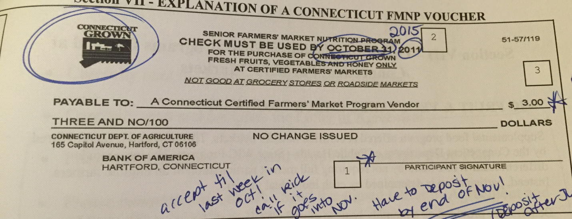
- Before accepting WIC FMNP & SFMNP vouchers:
  - Customer may only purchase fruit, vegetables, and fresh cut herbs with these vouchers. They may not purchase flowers using these vouchers.
  - Verify that the “Connecticut Grown” logo appears at the top left of the voucher.
  - Verify that the date displayed on top is a 2015 date.
  - Verify that the voucher amount is $3.00.
  - Participants signature must be signed on the designated line on the voucher.
  - Do not accept vouchers past the date displayed at the top of the voucher.
  - Do not give change.
  - Do not give cash in exchange for vouchers.
  - If item of purchase is less than $3.00 you may give the customer another item so that the total sale is equal to or exceeds the $3.00.
  - Do not accept a customer’s voucher from another farmer/vendor. They can call Rick Mascuga at CT Dept. of Agriculture for assistance: 860-713-2544
Money Matters (cont’d)

- All monies must be kept in the cash box and supervised by a volunteering adult throughout the market. These monies are not to be used for personal use.
- All monies and cash box must be delivered to one of the following school garden committee person after market close:
  - TREASURER: Jessica Cottrell: 203-816-1017
  - Back-Up 1: Kelly Pietro: 203-954-8434
  - Back-Up 2: Michele Urkawich: 203-246-0081

Market Break-Down Duties
6PM-6:45PM

- Break-down can begin close to 6PM as traffic winds down. Encourage your child to be very involved with this process!
- Do not drive your car up onto the green as this is prohibited.
- Collapse the tent and two tables.
- Place all supplies back into the plastic storage tub. Be sure the following are included:

  - Markers (Sharpies & dry erase)
  - Pens & crayons
  - Brown paper bags
  - Duct tape
  - String
  - Table cloth
  - CT Grown price signs
  - Scale
  - Vinyl banner
  - Extra jar labels
- The tent, tables, plastic storage tub, dry erase board, will all need to be returned to the storage container located behind the police department. Find a Farmers Market volunteer (green shirt). They will bring you to the storage container.
- Containers used to hold the crops (including glass jars) as well as any unsold seedlings/transplants need to be brought back to the school garden shed. The school garden is located in the rear of Monroe Elementary School to the right of the kindergarten entrance.
- At the close of the market you may take home unsold items. Please donate the remaining items to the Monroe Food Pantry. They will have a representative on site taking up a collection. Should you donate any cash please be sure to get a receipt that day. Place the receipt in the cash box.
- All monies and cash box must be delivered to one of the following school garden committee person after market close:
  - TREASURER: Jessica Cottrell: 203-816-1017
  - Back-Up 1: Kelly Pietro: 203-954-8434
  - Back-Up 2: Michele Urkawich: 203-246-0081
- The above people can also be contacted should you have any questions or concerns.

THANK YOU FOR MAKING OUR
FARMERS MARKET EFFORT A SUCCESS!

Thank you for
volunteering!

School Garden

